Dannevirke & Districts A & P Association

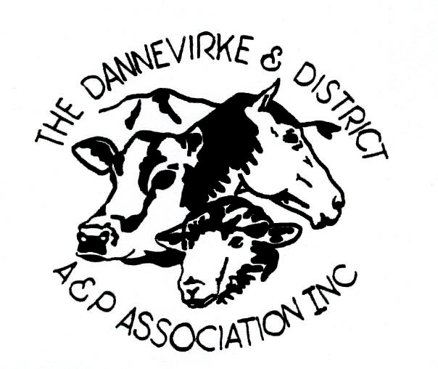

Presents

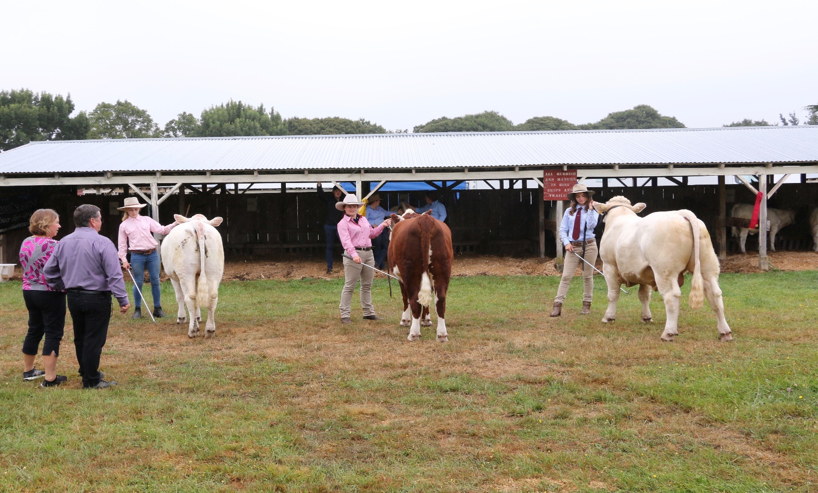 2021 A & P Show

6th February 2021

* All Breeds Beef Section
* All Breeds Lifestyle Section
* All Breeds Dairy Section
* Rules and Regulations
* Section Entry Conditions
* Entry Forms per Section

Dannevirke & Districts A & P Association

ALL BREEDS BEEF SECTION

Chief Beef Steward: Simon Collin

06 858 8045 or 027 636 3243

Saturday 6th February 2021 **- 9.00am Start**

**Judge - TBA**

1451 **Junior Stock Judging (to judge a team of four lead animals)**

1452 Paradors Class. Judged on the turnout of both Handler and Animal

**STEER CLASS**, born on or after 1st June 2018

1453 Best Lead Steer

1454 **BEST MEAT STEER (on hoof)**

1455 **YOUNG HANDLER COMPETITION,** under 23 years.

Note: Steers that have entered in the “Steer Class” can be used in the Handlers and Paradors/Turnout Competitions

BEEF JUDGING SECTION

1415 PGG Wrightson **COW 3 YEARS AND OVER**, with her own calf at foot, both to be paraded.

*Calf must be born on or after 1st June.*

1416 Dannevirke Suzuki **HEIFER 2 YEARS** with or without her own calf at foot.

1417 Kaitoa Herefords **YEARLING HEIFER**

*Note: If there are sufficient entries in total, then the option is provided to divide the class into two classes by age, comprising (Classes Junior Heifer and Senior Heifer).*

1418 Farmlands **HEIFER CALF**, born on or after 1st June 2019

*Note: If there are sufficient entries in total, then the option is provided to divide the class into two classes by age, comprising (Classes Junior Heifer and Senior Heifer calves).*

1419 **BULL 2 YEARS AND OVER**

1420 Rauriki Charolais **YEARLING BULL**

*Note: If there are sufficient entries in total, then the option is provided to divide the class into two classes by age, comprising (Classes Junior Bull and Senior Bull).*

1421 **BULL CALF**, born on or after 1st June 2019

*Note: If there are sufficient entries in total, then the option is provided to divide the class into two classes by age, comprising (Classes Junior Heifer and Senior Bull calves).*

1422 Vet Services – Dannevirke **OPEN PAIR, MALE OR FEMALE**, must be from same breed, be from Pedigree classes and owned by the Exhibitor

**SUPREME CHAMPION** Winner to receiveDannevirke A & P Association Meat & Wool Challenge Cup and Sash

**Winners of Classes 1415 – 1421 are elidable to enter the Supreme Champion Class**

Dannevirke & Districts A & P Association

ALL BREEDS LIFESTYLE SECTION

Chief Lifestyle Beef Steward: Simon Collin

06 858 8045 or 027 636 3243

Saturday 6th February 2021

Beef Cattle classes, and Lifestyle Cattle Classes will alternate the Judging ring

1515 **COW 3 YEARS AND OVER**, with her own calf at foot, both to be paraded.

Calf must be born on or after 1st June.

1516 **HEIFER 2 YEARS** with or without her own calf at foot.

1517 **YEARLING HEIFER**

Note: If there are sufficient entries in total, then the option is provided to divide the class into two classes by age, comprising (Classes Junior Heifer and Senior Heifer).

1518 **HEIFER CALF**, born on or after 1st June 2018

Note: If there are sufficient entries in total, then the option is provided to divide the class into two classes by age, comprising (Classes Junior Heifer and Senior Heifer calves).

1519 **BULL 2 YEARS AND OVER**

1520 **YEARLING BULL**

Note: If there are sufficient entries in total, then the option is provided to divide the class into two classes by age, comprising (Classes Junior Bull and Senior Bull).

1521 **BULL CALF**, born on or after 1st June 2018

Note: If there are sufficient entries in total, then the option is provided to divide the class into two classes by age, comprising (Classes Junior Heifer and Senior Bull calves).

1522  **OPEN PAIR, MALE OR FEMALE**, owned by the Exhibitor

**SUPREME CHAMPION “LIFESTYLE” CATTLE EXHIBIT OF SHOW –**

Donated by Boxpalm Dexter

Winners of Classes 1515 – 1521 are eligible to enter the Supreme Champion Lifestyle Class

***Dannevirke & Districts A & P Association***

***ALL BREEDS DAIRY SECTION***

***Chief Dairy Steward: Hennie Verwaayen***

***06 374 6775 or 021 2983959***

***Saturday 6th February 2021 – 10.00 Start***

***Judge TBC***

**1756 Junior Stock Judging (to be judged from a team of four animals)**

**YOUNG HANDLER COMPETITION**

1753 All Breeds Junior Handler Class

Note: 12 years and under, at the time of entry. To parade only heifer calves or yearling heifers.

1754 All Breeds Intermediate Handler Class

Note: 13 – 16 years inclusive, at the time of entry. To parade only heifer calves or yearling heifers

1755 All Breeds Senior Handler Class

Note: 17 – 26 years inclusive, at the time of entry. To parade only heifer calves or yearling heifers.

1730 **SENIOR** **HEIFER CALF**, born on or after 1st June 2019 to 1 August 2019

Note: If there are sufficient entries in total, then the option is provided to divide the class into two classes by age, comprising (Classes Junior Heifer and Senior Heifer calves).

1731 **JUNIOR** **HEIFER CALF**, born on or after 1 August 2019

Note: If there are sufficient entries in total, then the option is provided to divide the class into two classes by age, comprising (Classes Junior Heifer and Senior Heifer calves).

1732 **SENIOR** **YEARLING HEIFER** born on or after 1st June 2019 to 1st August 2019

Note: If there are sufficient entries in total, then the option is provided to divide the class into two classes by age, comprising (Classes Junior Heifer and Senior Heifer).

1733 **JUNIOR** **YEARLING HEIFER** born on or after 1 August 2019

Note: If there are sufficient entries in total, then the option is provided to divide the class into two classes by age, comprising (Classes Junior Heifer and Senior Heifer).

1734 **PAIR OF YOUNG STOCK**

Note: 1 calf (Junior or Senior) and one yearling (Junior or Senior).

1735 **SENIOR** **BULL CALF**, born on or after 1st June 2019 to 1st August 2019

Note: If there are sufficient entries in total, then the option is provided to divide the class into two classes by age, comprising (Classes Junior Bull and Senior Bull calves).

1736 **JUNIOR** **BULL CALF**, born on or after 1 August 2019

*Note: If there are sufficient entries in total, then the option is provided to divide the class into two classes by age, comprising (Classes Junior Bull and Senior Bull calves).*

**Diary Supreme Champion will be contested by**

**winners of classes 1730-1733 and 1735-1736**

**RULES AND REGULATIONS**

The Rules and Regulations as issued by the Royal Agricultural Society of New Zealand (Inc) for the governance and conduct of A & P Shows have been adopted by the Dannevirke & Districts A & P Association. It is the responsibility of exhibitors to be conversant with these rules.

* All cattle must be entered in the name of the bona-fide owner. The owner of the cattle must be a member of their respective breed society.
* The date of birth of all breeding cattle must be stated at time of entry. All beef cows three years and over must be shown with own calf at foot, born on or after 1st June in the current Show Season. All purebred cattle shall be led into the Show Ring when required by stewards or judges.
* The age of cattle shall be computed as at 1st June.
  + - NB: As the age of all cattle is determined from the 1st June in each year, all animals shall be deemed to be one year older on this date.
* All bulls twelve months old and over, must be rung and be led by the ring and be under adequate supervision when being shown. All bulls two years and over must have two leaders. Bulls stalled in the Pavilion must be securely tied in the stalls with a good strong halter and rope as well as a strong neck chain.
* In the case of all beef females, yearlings and over, must be led with a nose clip (not ring) at all times during the Show
* Dannevirke & Districts A & P Association reserves the right to amalgamate classes where there are insufficient entries.

**GENERAL**

* All Exhibits must be shown up to their respective ages and no two year old may be shown as a three year old and no yearling may be shown in a two or three year old class.
* Exhibitors are requested not to tether stock in Judging Rings.
* All cattle entered in the purebred classes must be entered, if one year old or over, in a Herd Book of the breed. If under one year of age, they must be eligible for entry. The names and pedigree of all such cattle must be stated on the Entry Form and if the exhibitor is not the breeder, the breeders name must also be stated.
* No stock shall be brought to the Showgrounds earlier than 1 day prior to the Show unless permission has been given from the Chief Steward.
* All electrical equipment must have a certified lead.
* The cattle entered for the Show must be considered Purebred by their respective Breed Society
* Entries will not be accepted unless they are on the Dannevirke & Districts A & P Association Beef Entry Form.
* Cattle “Showing Rings” will be located within the Cattle Section
* All entries will be paraded in age and catalogue order.
* Winners of Class 1415 to 1421 are eligible to the Supreme Champion Award. There is only one award and second place getters need not standby.
* Protests have to be lodged with the Chief Steward, 15 minutes after the class has finished. A panel of three will hear the protest, and their decision is final.
* Entries will not be accepted after the 26th of January for all cattle entered in the Lead Cattle Competition

**Lifestyle Section:**

* Entries will not be accepted unless they are on the Dannevirke & Districts A & P Association Lifestyle Breed Entry Form.
* Lifestyle classes will be offered in the Schedule. If numbers are not sufficient for each respective class then the Dannevirke & Districts A & P Association Beef Committee reserves the right to amalgamate classes with the mainstream breeds.
* For breeds to qualify for the Lifestyle Section it will be up to the discretion of the Dannevirke & Districts A & P Association Beef Committee.
* Winners of Class 1515 to 1521 are eligible to the Supreme Champion Lifestyle Cattle Award. There is only one award and second place getters need not standby.
* A Supreme Lifestyle award will be awarded. In the event of not enough entries for a Lifestyle class or section the appointed judge will nominate which animals shall compete in the Supreme Award. One representative of each class will contest the Supreme Award.
* If a breeder enters the Lifestyle section they are not eligible for the mainstream animal award.
* A valid RAS High

received without a Passport will **not** be accepted.

land Passport **must** accompany all Highland Cattle entries.

* Entries will not be accepted after the 29th of January

**STALLING OF ENTRIES**

In the event of catalogued entries not being exhibited at the Show, the Chief Steward shall have the right to re-allocated such stall spaces.

**Note:** **IT IS A REQUIREMENT OF ALL EXHIBITORS TO KEEP THEIR AREA CLEAN AND TIDY THROUGHOUT THE DURATION OF THE SHOW.**

Woodchip bedding will be available for all animals. Exhibitors wishing to feed meal or dry stock feed should bring suitable containers with them. This must be removed at the end of the Show and placed in an appropriate bin. Water troughs will not be available at the Show owing to a Bio Security risk, Exhibitors are asked to provide their own water troughs/buckets.

**TB TESTING and NAIT**

All cattle including yearlings entered for this Show must be from a TB free and accredited Herd within the preceding 12 months. Cattle from a TB and accredited Herd within a declared Movement Control Area must be tested and passed with 60 days of movement.

**A copy of the Test Certificate must accompany all entry forms.**

Checks will be made for TB declaration cards on stock arrival.

All animals must comply with current Animal Health Board and Nait regulations. Nait numbers must accompany all cattle entered into the 2020 Dannevirke A & P Show

For cattle being moved from 1 July 2012: A NAIT approved RFID tag is mandatory for all movements of cattle, including day old calves. NAIT approved RFID cattle tags are white only. Please do not removed tags if cattle are identified with Animal Health Board or MINDA tags. As of 1 July 2012 a secondary tag is no longer required under the new NAIT scheme. All animals being exhibited at the Show come under the standard identification and SAD regulations. These cattle with require the NAIT approved RFID tag. It is the livestock exhibitors responsibility to record all animal movements with NAIT 48 hours prior to leaving the farm/property for the Show and then within 48 hours of returning to the farm/property from the Show. All cattle entered in the Lead Cattle section must provide Nait Numbers

1. Animals are from a clear status herd
2. Routine TB testing requirements are complete

*(To arrange a TB test please contact TB free on 0800 482 4636)*

1. Animals are from a Movement Control Area
2. If yes to 3, pre movement is completed within 60 days of the movement to Show
3. All animals presented for showing will be compliant with NAIT requirements

*(This will include recording of NAIT movement and identification with approved RFID ear tag).*

* The Cattle Committee requests at all times a minimum of two meters apart between cattle, as part of the Bio Security Policy
* Wash bays will be partitioned as part of our Bio Security Policy. The Cattle Committee requests owing to the size of the Wash Bays that All Beef Cattle have the use of the Wash Bays between 5.00am and 8.30am. Dairy Cattle will have the use of the Wash Bays between 8.40am and 10.00am
* Upon arrival at the Dannevirke A & P Showgrounds, all cattle will be “scanned “to meet their Nait requirements. Entries will not be accepted if Nait requirements are not met. Cattle which do not meet Nait requirements may be asked to leave the showgrounds
* All cattle must be unloaded and loaded from designed “Loading Zone”, located at the northern end of the cattle stalls. Owing to Bio Security concerns this condition will be strictly enforced by the Bio Security Officer

**Dannevirke & Districts A & P Association’s NAIT number is: 504317**

***Entry into Showgrounds for this event is through the gates at the bottom***

***of Neptune Street.***

**Many thanks to our magnificent sponsors, including by not exclusive to:**

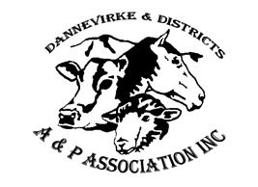

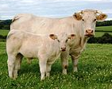

Rauriki Charolais

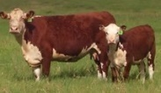

Kaitoa Polled

Herefords





[](https://www.google.co.nz/url?sa=i&rct=j&q=&esrc=s&source=images&cd=&cad=rja&uact=8&ved=0ahUKEwiFqsjT5K_YAhVKNpQKHW08CCwQjRwIBw&url=https://www.seeklogo.net/manufacturing-logos/fonterra-vector-logo-73602.html&psig=AOvVaw0YwJIUbmWFsfW-sloXLfhI&ust=1514656305222635)

**ENTRY FEES, PRIZE MONEY AND MEMBERSHIP**

* Application for membership will be welcomed from prospective members on the basis of a continuing commitment.
* All stated Entry Fees and Prize Money are GST Inclusive.
* Entry fees also includes having wood shavings in stalls.

Entry Fee : $15.00 per class

Single Membership $15.00 Family Membership $30.00

Prize Money will be: 1st – 3rd To be confirmed

**Enter by:** **Post/Cheque**

Please complete your entry form, take a photocopy for your own records and then post signed forms together with your cheque made out to:

Dannevirke & Districts A & P Association

P O Box 50

DANNEVIRKE 4942

**Email and Direct Credit.**

Email your entry to [dvkap@xtra.co.nz](mailto:dvkap@xtra.co.nz) and pay by direct credit to

Dannevirke A & P Association, ANZ Dannevirke 06-0613-0041542-00

Please use Beef and your Surname as references.

Please contact Simon Collin on 06 858 8045 or Wendy Lansdown on or email 063742767 [dvkap@xtra.co.nz](mailto:dvkap@xtra.co.nz)

Our website is: www. dannevirkedistrictsapshow.co.nz

|  |  |
| --- | --- |
|  | **Dannevirke A&P Show Entry Form** |

Please complete this form and return to The Dannevirke A&P Association.

By email to: dvkap@xtra.co.nz By post to: P O Box 50

Dannevirke 4942

|  |  |  |  |
| --- | --- | --- | --- |
| **Person In Charge Of Animals (PICA) Details** | | | |
| Name |  | | |
| Trading Name |  | | |
| Address |  |  |  |
| Email |  | | |
| Phone |  | | |
| NAIT Number |  | | |
|  | | | |
| **Animal Exhibit Details** | | | |

*When completing this section please provide details of all possible exhibits attending the 2021 show. Final numbers can be provided closer to the commencement date.*

|  |  |  |  |  |  |  |
| --- | --- | --- | --- | --- | --- | --- |
| **Class No** | **RFID Number** | **NAIT Visual ID** | **Animal Reg No** | **Exhibitor** | **DOB** | **Entry Fees** |
|  |  |  |  |  |  |  |
|  |  |  |  |  |  |  |
|  | *982 000123456789* | *ABCD-12-34* | *Simmental* |  | *1 y/o* | *Bull* |
|  |  |  |  |  |  |  |
|  |  |  |  |  |  |  |
|  |  |  |  |  |  |  |
|  |  |  |  |  |  |  |
|  |  |  |  |  |  |  |
|  |  |  |  |  |  |  |

***Please note that any cattle that are non NAIT compliant will not be permitted to enter the show grounds.***